DESIGN AND IMPLEMENTATION OF A
DATABASE MANAGEMENT SYSTEM FOR
CAR RENTAL RESERVATION AND
VEHICLE RETURN MANAGEMENT SYSTEM
PROJECT REPORT

DETAIL | VALUE
Student Name | Koneri Mithul
Roll Number | 25WU0102129
Class / Section | AIML Panthers
Course | Database Management Systems (DBMS)
Faculty / Guide | Dr. Kiran Mayee Adavala
Academic Year | 2026–27
Project Number | Project 19

Submitted in partial fulfillment of the DBMS Course Project-Based Learning requirements.

TABLE OF CONTENTS
- 1. Cover Page
- 2. Abstract
- 3. Introduction and Problem Statement
- 4. Objectives and Scope
- 5. Software and Hardware Requirements
- 6. ER Diagram
- 7. Relational Schema and Normalization
- 8. Data Dictionary (Table Structure, Data Types, Constraints)
- 9. SQL Commands Used (DDL, DML) with Sample Outputs
- 10. Queries with Outputs, including the Presentation-II Query
- 11. UI Design and Screenshots
- 12. Implementation Details (Technology Stack, DB Connectivity, Key Code Snippets)
- 13. Testing (Test Cases and Results)
- 14. Conclusion and Future Enhancements
- 15. References
- 16. Appendix: GitHub Repository Link

2. Abstract
The Car Rental Reservation and Vehicle Return Management System is a relational database management system designed to support the complete rental lifecycle of a vehicle. The system manages branches, vehicle categories, vehicles, customers, rate plans, reservations, rentals, pickup and return inspections, damages, invoices and payments.
The database is normalized to Third Normal Form (3NF) and implemented in MySQL with primary keys, foreign keys, UNIQUE, NOT NULL, CHECK and DEFAULT constraints. Business rules such as prevention of overlapping rentals, valid driving licence at pickup, valid return time, valid odometer/fuel readings and non-negative monetary values are enforced using database constraints and triggers.
A Python Tkinter/ttk desktop application provides a working interface connected to the MySQL database. It supports CRUD operations, availability search and reporting. The final implementation demonstrates live insertion, viewing and deletion of records with changes reflected directly in the database.

3. Introduction and Problem Statement

3.1 Introduction
Car-rental agencies maintain information about vehicles, customers, reservations, rentals, inspections, damages, billing and payments. A reliable DBMS is required to keep these records consistent and to provide quick access to availability and operational reports.

3.2 Problem Statement
Manual or disconnected rental records can lead to double booking, incorrect vehicle availability, expired driving licences, disputes about vehicle condition, missing damage charges and inconsistent billing. The project addresses these issues through a centralized relational database and a connected application.

3.3 Users
USER | RESPONSIBILITIES
Rental Staff | Create reservations, issue vehicles, record inspections and process returns.
Branch Manager | Monitor fleet availability, utilization, revenue and damages.
Billing / Accounts Staff | Generate invoices and record payments.
System Administrator | Maintain database records, integrity rules and system configuration.
Customer-facing Staff | Maintain customer and licence information and search availability.

3.4 Functional Requirements
- Customer management
- Vehicle and category management
- Rate-plan management
- Reservation creation/cancellation
- Vehicle issue and rental tracking
- Pickup/return inspection
- Damage recording
- Charge and invoice management
- Payment recording
- Availability search
- Operational reporting
- CRUD operations and validation

4. Objectives and Scope

4.1 Objectives
- Design a relational database for the complete car-rental lifecycle.
- Normalize the database up to Third Normal Form (3NF).
- Enforce data integrity using PK, FK, UNIQUE, NOT NULL, CHECK and DEFAULT constraints.
- Prevent overlapping rentals and enforce licence/return/odometer/fuel rules.
- Provide a Python application connected to MySQL.
- Support CRUD operations, availability search and meaningful reports.
- Demonstrate transaction awareness, indexing, input validation and systematic testing.

4.2 Scope
The system covers multi-branch vehicle inventory, customer and licence information, category-based pricing, reservations, rentals, inspections, damage records, invoicing and payments. It also provides fleet availability, overdue rental, utilization, damage, branch revenue and customer-history reporting.
The current project scope is a desktop academic prototype. External payment gateways, mobile applications, GPS tracking and enterprise authentication are outside the implemented scope.

5. Software and Hardware Requirements
CATEGORY | REQUIREMENT | PURPOSE
Operating System | Windows 10/11 or compatible OS | Development and execution
Language | Python 3.x | Application layer
GUI | Tkinter / ttk | Desktop user interface
Database | MySQL 8.x | Relational data storage
Connector | mysql-connector-python | Python–MySQL connectivity
IDE | Visual Studio Code | Development and execution
Database Tool | MySQL Workbench / MySQL CLI | Database administration and verification
Version Control | Git / GitHub | Project submission and history
Processor | Dual-core or better | Application execution
RAM | 4 GB minimum; 8 GB recommended | Development environment
Storage | At least 1 GB free | Source code, database tools and report

6. ER Diagram
The conceptual ER model contains 11 entities and represents the main operational relationships of the rental system. Fuel readings are represented through the Inspection entity because each fuel reading belongs to a specific pickup or return inspection.
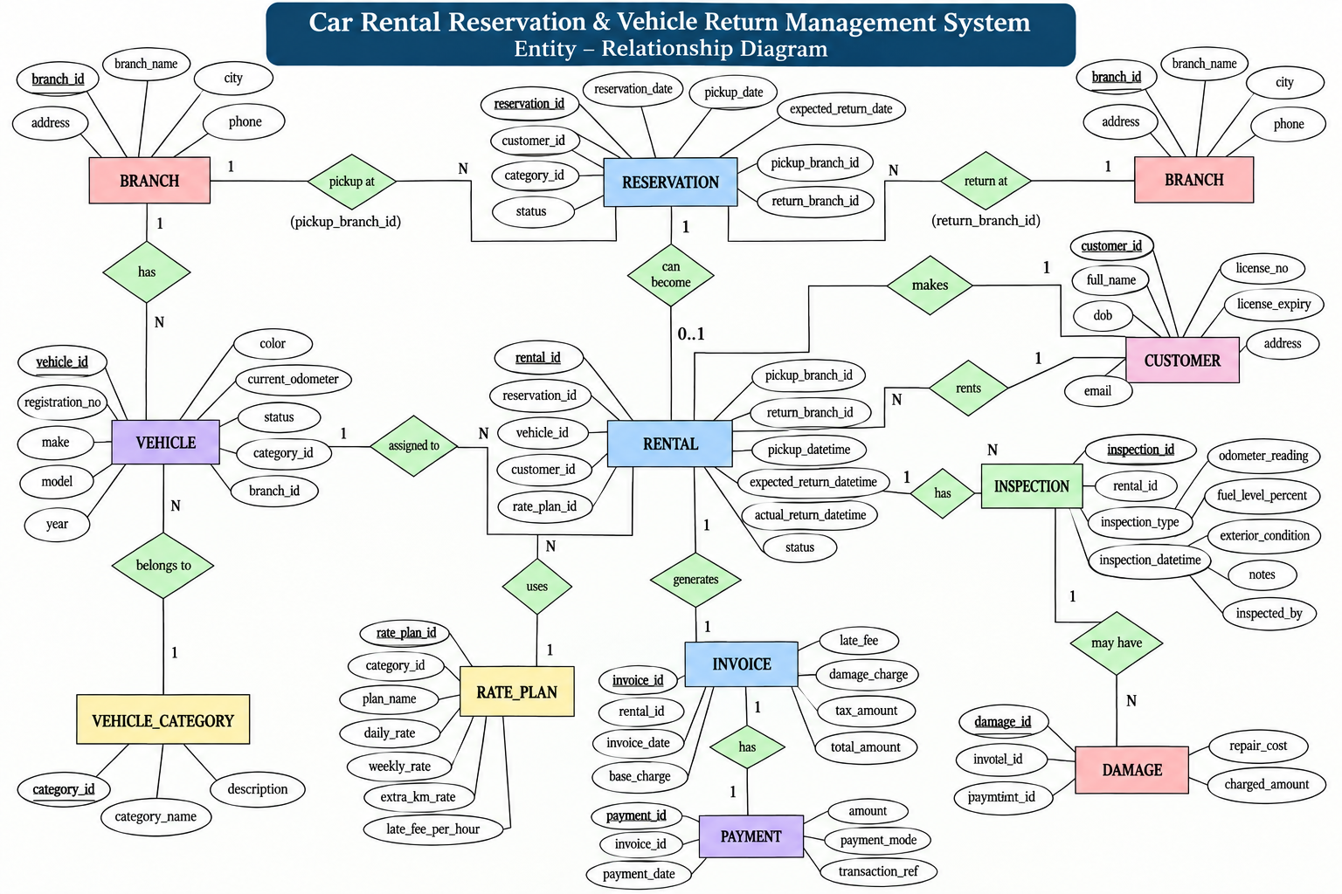
Figure 1. Entity–Relationship diagram for the Car Rental Reservation and Vehicle Return Management System.

6.1 Key Relationships and Cardinalities
- Branch 1:N Vehicle
- VehicleCategory 1:N Vehicle
- VehicleCategory 1:N RatePlan
- Customer 1:N Reservation
- Customer 1:N Rental
- Branch 1:N Reservation (pickup branch)
- Branch 1:N Reservation (return branch)
- Reservation 1:0..1 Rental
- Vehicle 1:N Rental
- RatePlan 1:N Rental
- Rental 1:N Inspection
- Rental 1:N Damage
- Rental 1:1 Invoice
- Invoice 1:N Payment

6.2 Business Rules Represented in the Design
- No overlapping rentals for the same vehicle
- Valid driving licence at pickup
- Return after pickup
- Return odometer ≥ pickup odometer
- Fuel level between 0 and 100%
- Non-negative invoice, damage and payment amounts

7. Relational Schema and Normalization

7.1 Relational Schema
- Branch(branch_id PK, branch_name, city, address, phone)
- VehicleCategory(category_id PK, category_name, description)
- Vehicle(vehicle_id PK, registration_no UK, category_id FK, branch_id FK, make, model, year, color, current_odometer, status)
- Customer(customer_id PK, full_name, dob, phone UK, email UK, license_no UK, license_expiry, address)
- RatePlan(rate_plan_id PK, category_id FK, plan_name, daily_rate, weekly_rate, extra_km_rate, late_fee_per_hour)
- Reservation(reservation_id PK, customer_id FK, category_id FK, pickup_branch_id FK, return_branch_id FK, reservation_date, pickup_date, expected_return_date, status)
- Rental(rental_id PK, reservation_id FK NULL, vehicle_id FK, customer_id FK, rate_plan_id FK, pickup_branch_id FK, return_branch_id FK, pickup_datetime, expected_return_datetime, actual_return_datetime, status)
- Inspection(inspection_id PK, rental_id FK, inspection_type, inspection_datetime, odometer_reading, fuel_level_percent, exterior_condition, notes, inspected_by)
- Damage(damage_id PK, rental_id FK, inspection_id FK NULL, description, repair_cost, charged_amount)
- Invoice(invoice_id PK, rental_id FK UNIQUE, invoice_date, base_charge, extra_km_charge, late_fee, damage_charge, tax_amount, total_amount)
- Payment(payment_id PK, invoice_id FK, payment_date, amount, payment_mode, transaction_ref)

7.2 Functional Dependencies
DETERMINANT | FUNCTIONALLY DETERMINED ATTRIBUTES
vehicle_id | registration_no, category_id, branch_id, current_odometer, status, make, model, year, color
customer_id | full_name, dob, phone, email, license_no, license_expiry, address
rental_id | vehicle_id, customer_id, rate_plan_id, pickup_datetime, expected_return_datetime, actual_return_datetime, status
invoice_id | rental_id, invoice_date, base_charge, extra_km_charge, late_fee, damage_charge, tax_amount, total_amount
payment_id | invoice_id, payment_date, amount, payment_mode, transaction_ref

7.3 Normalization to 3NF
1NF: All attributes are atomic and repeating groups are separated. For example, payments are stored as individual Payment rows rather than multiple payment columns in Invoice.
2NF: Every non-key attribute in the entity tables depends on the whole primary key. Since the design uses single-attribute surrogate primary keys, partial dependency is eliminated.
3NF: Non-key attributes do not depend transitively on another non-key attribute. For example, vehicle category details and rates are separated from Vehicle into VehicleCategory and RatePlan rather than storing category names and rates repeatedly in Vehicle.

8. Data Dictionary (Table Structure, Data Types, Constraints)

Branch
COLUMN | DATA TYPE | KEY / CONSTRAINT | NULL / DEFAULT
branch_id | INT | PK, AUTO_INCREMENT | NOT NULL
branch_name | VARCHAR(80) | — | NOT NULL
city | VARCHAR(50) | — | NOT NULL
address | VARCHAR(150) | — | NULL
phone | VARCHAR(15) | — | NOT NULL

VehicleCategory
COLUMN | DATA TYPE | KEY / CONSTRAINT | NULL / DEFAULT
category_id | INT | PK, AUTO_INCREMENT | NOT NULL
category_name | VARCHAR(40) | UNIQUE | NOT NULL
description | VARCHAR(150) | — | NULL

Vehicle
COLUMN | DATA TYPE | KEY / CONSTRAINT | NULL / DEFAULT
vehicle_id | INT | PK, AUTO_INCREMENT | NOT NULL
registration_no | VARCHAR(15) | UNIQUE | NOT NULL
category_id | INT | FK → VehicleCategory | NOT NULL
branch_id | INT | FK → Branch | NOT NULL
make | VARCHAR(40) | — | NOT NULL
model | VARCHAR(40) | — | NOT NULL
year | INT | CHECK 1990–2100 | NOT NULL
color | VARCHAR(20) | — | NULL
current_odometer | INT | CHECK ≥ 0; DEFAULT 0 | NOT NULL
status | VARCHAR(15) | CHECK allowed statuses; DEFAULT Available | NOT NULL

Customer
COLUMN | DATA TYPE | KEY / CONSTRAINT | NULL / DEFAULT
customer_id | INT | PK, AUTO_INCREMENT | NOT NULL
full_name | VARCHAR(80) | — | NOT NULL
dob | DATE | — | NOT NULL
phone | VARCHAR(15) | UNIQUE | NOT NULL
email | VARCHAR(80) | UNIQUE | NULL
license_no | VARCHAR(20) | UNIQUE | NOT NULL
license_expiry | DATE | — | NOT NULL
address | VARCHAR(150) | — | NULL

RatePlan
COLUMN | DATA TYPE | KEY / CONSTRAINT | NULL / DEFAULT
rate_plan_id | INT | PK, AUTO_INCREMENT | NOT NULL
category_id | INT | FK → VehicleCategory | NOT NULL
plan_name | VARCHAR(40) | — | NOT NULL
daily_rate | DECIMAL(10,2) | CHECK > 0 | NOT NULL
weekly_rate | DECIMAL(10,2) | CHECK > 0 | NOT NULL
extra_km_rate | DECIMAL(6,2) | CHECK ≥ 0; DEFAULT 0 | NOT NULL
late_fee_per_hour | DECIMAL(6,2) | CHECK ≥ 0; DEFAULT 0 | NOT NULL

Reservation
COLUMN | DATA TYPE | KEY / CONSTRAINT | NULL / DEFAULT
reservation_id | INT | PK, AUTO_INCREMENT | NOT NULL
customer_id | INT | FK → Customer | NOT NULL
category_id | INT | FK → VehicleCategory | NOT NULL
pickup_branch_id | INT | FK → Branch | NOT NULL
return_branch_id | INT | FK → Branch | NOT NULL
reservation_date | DATETIME | DEFAULT CURRENT_TIMESTAMP | NOT NULL
pickup_date | DATETIME | — | NOT NULL
expected_return_date | DATETIME | CHECK > pickup_date | NOT NULL
status | VARCHAR(15) | CHECK allowed statuses; DEFAULT Booked | NOT NULL

Rental
COLUMN | DATA TYPE | KEY / CONSTRAINT | NULL / DEFAULT
rental_id | INT | PK, AUTO_INCREMENT | NOT NULL
reservation_id | INT | FK → Reservation | NULL
vehicle_id | INT | FK → Vehicle | NOT NULL
customer_id | INT | FK → Customer | NOT NULL
rate_plan_id | INT | FK → RatePlan | NOT NULL
pickup_branch_id | INT | FK → Branch | NOT NULL
return_branch_id | INT | FK → Branch | NOT NULL
pickup_datetime | DATETIME | — | NOT NULL
expected_return_datetime | DATETIME | CHECK > pickup | NOT NULL
actual_return_datetime | DATETIME | CHECK > pickup when present | NULL
status | VARCHAR(15) | CHECK Active/Returned/Overdue; DEFAULT Active | NOT NULL

Inspection
COLUMN | DATA TYPE | KEY / CONSTRAINT | NULL / DEFAULT
inspection_id | INT | PK, AUTO_INCREMENT | NOT NULL
rental_id | INT | FK → Rental | NOT NULL
inspection_type | VARCHAR(10) | CHECK Pickup/Return | NOT NULL
inspection_datetime | DATETIME | DEFAULT CURRENT_TIMESTAMP | NOT NULL
odometer_reading | INT | CHECK ≥ 0 | NOT NULL
fuel_level_percent | INT | CHECK 0–100 | NOT NULL
exterior_condition | VARCHAR(20) | DEFAULT Good | NULL
notes | VARCHAR(200) | — | NULL
inspected_by | VARCHAR(60) | — | NULL

Damage
COLUMN | DATA TYPE | KEY / CONSTRAINT | NULL / DEFAULT
damage_id | INT | PK, AUTO_INCREMENT | NOT NULL
rental_id | INT | FK → Rental | NOT NULL
inspection_id | INT | FK → Inspection | NULL
description | VARCHAR(200) | — | NOT NULL
repair_cost | DECIMAL(10,2) | CHECK ≥ 0; DEFAULT 0 | NOT NULL
charged_amount | DECIMAL(10,2) | CHECK ≥ 0; DEFAULT 0 | NOT NULL

Invoice
COLUMN | DATA TYPE | KEY / CONSTRAINT | NULL / DEFAULT
invoice_id | INT | PK, AUTO_INCREMENT | NOT NULL
rental_id | INT | FK → Rental; UNIQUE | NOT NULL
invoice_date | DATETIME | DEFAULT CURRENT_TIMESTAMP | NOT NULL
base_charge | DECIMAL(10,2) | CHECK ≥ 0; DEFAULT 0 | NOT NULL
extra_km_charge | DECIMAL(10,2) | CHECK ≥ 0; DEFAULT 0 | NOT NULL
late_fee | DECIMAL(10,2) | CHECK ≥ 0; DEFAULT 0 | NOT NULL
damage_charge | DECIMAL(10,2) | CHECK ≥ 0; DEFAULT 0 | NOT NULL
tax_amount | DECIMAL(10,2) | CHECK ≥ 0; DEFAULT 0 | NOT NULL
total_amount | DECIMAL(10,2) | CHECK ≥ 0 | NOT NULL

Payment
COLUMN | DATA TYPE | KEY / CONSTRAINT | NULL / DEFAULT
payment_id | INT | PK, AUTO_INCREMENT | NOT NULL
invoice_id | INT | FK → Invoice | NOT NULL
payment_date | DATETIME | DEFAULT CURRENT_TIMESTAMP | NOT NULL
amount | DECIMAL(10,2) | CHECK > 0 | NOT NULL
payment_mode | VARCHAR(15) | CHECK Cash/Card/UPI/NetBanking | NOT NULL
transaction_ref | VARCHAR(40) | — | NULL

9. SQL Commands Used (DDL, DML) with Sample Outputs

9.1 Database and Table Creation (DDL)
CREATE DATABASE car_rental_db;
USE car_rental_db;
CREATE TABLE Vehicle (
vehicle_id INT AUTO_INCREMENT PRIMARY KEY,
registration_no VARCHAR(15) NOT NULL UNIQUE,
category_id INT NOT NULL,
branch_id INT NOT NULL,
...
);

The complete project SQL file contains all 11 CREATE TABLE statements, indexes, triggers and sample data. The implemented schema uses PK/FK/UNIQUE/NOT NULL/CHECK/DEFAULT constraints.

9.2 DML – Sample Insert
INSERT INTO Customer
(full_name, dob, phone, email, license_no, license_expiry, address)
VALUES
('Arjun Rao','1995-04-12','9876500001','arjun@example.com',
'DLTS1001','2027-06-30','Kondapur, Hyderabad');

9.3 Sample Database Output
OBJECT | CURRENT PROJECT DATA
Branches | 4
Vehicle Categories | 4
Vehicles | 12
Customers | 9
Rate Plans | 5
Reservations | 10
Rentals | 9
Inspections | 17
Damages | 3
Invoices | 7
Payments | 8

These counts correspond to the populated project database and are also reflected in the working application dashboard for the principal counters.

10. Queries with Outputs, including the Presentation-II Query

10.1 Fleet Availability – JOIN Query
SELECT v.registration_no, v.make, v.model,
vc.category_name, b.branch_name
FROM Vehicle v
JOIN VehicleCategory vc ON v.category_id = vc.category_id
JOIN Branch b ON v.branch_id = b.branch_id
WHERE v.status = 'Available';

Expected output columns: registration number, make, model, category and branch for vehicles currently marked Available.

10.2 Overdue Rentals
SELECT r.rental_id, c.full_name, v.registration_no,
r.expected_return_datetime
FROM Rental r
JOIN Customer c ON r.customer_id = c.customer_id
JOIN Vehicle v ON r.vehicle_id = v.vehicle_id
WHERE r.actual_return_datetime IS NULL
AND r.expected_return_datetime < NOW();

10.3 Vehicle Utilization – Aggregate
SELECT v.registration_no,
COUNT(r.rental_id) AS total_rentals,
SUM(DATEDIFF(COALESCE(r.actual_return_datetime,NOW()),
r.pickup_datetime)) AS total_days_rented
FROM Vehicle v
LEFT JOIN Rental r ON v.vehicle_id = r.vehicle_id
GROUP BY v.vehicle_id, v.registration_no
ORDER BY total_days_rented DESC;

10.4 Branch Revenue
SELECT b.branch_name, SUM(i.total_amount) AS total_revenue
FROM Invoice i
JOIN Rental r ON i.rental_id = r.rental_id
JOIN Branch b ON r.pickup_branch_id = b.branch_id
GROUP BY b.branch_id, b.branch_name
ORDER BY total_revenue DESC;

10.5 Customer Rental History
SELECT c.full_name, v.registration_no,
r.pickup_datetime, r.actual_return_datetime,
i.total_amount
FROM Rental r
JOIN Customer c ON r.customer_id = c.customer_id
JOIN Vehicle v ON r.vehicle_id = v.vehicle_id
LEFT JOIN Invoice i ON i.rental_id = r.rental_id
WHERE c.customer_id = 1
ORDER BY r.pickup_datetime;

10.6 Nested Subquery
SELECT c.full_name, SUM(i.total_amount) AS total_spent
FROM Customer c
JOIN Rental r ON c.customer_id = r.customer_id
JOIN Invoice i ON r.rental_id = i.rental_id
GROUP BY c.customer_id, c.full_name
HAVING SUM(i.total_amount) >
(SELECT AVG(total_amount) FROM Invoice);

10.7 Views
CREATE OR REPLACE VIEW vw_fleet_availability AS
SELECT v.vehicle_id, v.registration_no, vc.category_name,
b.branch_name, v.status
FROM Vehicle v
JOIN VehicleCategory vc ON v.category_id = vc.category_id
JOIN Branch b ON v.branch_id = b.branch_id
WHERE v.status = 'Available';

The project SQL also defines views for overdue rentals, branch revenue and the remaining report outputs. The exact faculty-issued Presentation-II query was not present in the retrieved final-instructions file; the fleet-availability query above is included as the project's representative Presentation-II reporting query.

11. UI Design and Screenshots
The final application is a Python Tkinter/ttk desktop application connected directly to MySQL. The interface exposes the database through table-specific CRUD tabs and additional availability/reporting modules.
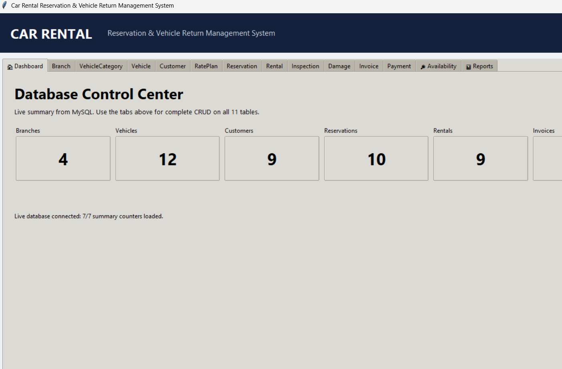
Figure 2. Working application dashboard connected to the project MySQL database.

11.1 UI Modules
SCREEN / MODULE | PURPOSE
Dashboard | Live database summary and navigation
Branch | CRUD for branch records
VehicleCategory | CRUD for vehicle categories
Vehicle | CRUD for fleet vehicles
Customer | CRUD for customer/licence records
RatePlan | CRUD for pricing plans
Reservation | CRUD for booking records
Rental | CRUD for rental transactions
Inspection | CRUD for pickup/return inspection
Damage | CRUD for damage records
Invoice | CRUD for billing
Payment | CRUD for payments
Availability | Search available vehicles
Reports | Operational reports and summaries

11.2 Required Before/After Evidence
- Customer INSERT – before and after
- Customer VIEW – inserted row visible in UI
- MySQL SELECT – inserted row visible in database
- Customer DELETE – before and after
- MySQL SELECT – deleted row no longer present
- Screenshots of each UI screen/module for final submission

12. Implementation Details (Technology Stack, DB Connectivity, Key Code Snippets)

12.1 Technology Stack
LAYER | TECHNOLOGY | ROLE
GUI | Python Tkinter / ttk | Forms, tabs, buttons and tables
Application | Python 3.x | CRUD, validation and report execution
Database | MySQL 8.x | Persistent relational storage
Connector | mysql-connector-python | Database connectivity
Development | Visual Studio Code | Source-code development
Database Administration | MySQL Workbench / CLI | SQL execution and verification

12.2 Database Connectivity
DB_CONFIG = {
"host": "localhost",
"port": 3306,
"user": "root",
"password": "<configured locally>",
"database": "car_rental_db",
}
import mysql.connector
connection = mysql.connector.connect(**DB_CONFIG)

The final working application was tested against the local car_rental_db database. The dashboard displayed live counts from MySQL, confirming successful connectivity.

12.3 CRUD and Transaction Handling
- SQL operations use parameterized values rather than string concatenation.
- Successful INSERT/UPDATE/DELETE operations are committed.
- Exceptions trigger rollback where applicable and are reported to the user.
- Refresh operations reload records from MySQL so the UI reflects current database state.
- Availability and report modules execute SQL queries/views against the same database.

12.4 Database Triggers
- trg_no_overlap_rental – prevents overlapping active/overdue rentals for the same vehicle.
- trg_valid_license – prevents rental issue when the customer licence has expired.
- trg_valid_odometer – prevents a return odometer lower than the pickup reading.
- trg_vehicle_status_on_issue – sets vehicle status to Rented after rental insertion.
- trg_vehicle_status_on_return – sets vehicle status back to Available when a rental is returned.

13. Testing (Test Cases and Results)
ID | TEST | EXPECTED RESULT | STATUS
TC-01 | Database connection | Dashboard loads live counters | PASS
TC-02 | Customer insertion | New customer row created | PASS
TC-03 | Customer viewing | Inserted row visible after refresh | PASS
TC-04 | Customer deletion | Selected record removed | PASS
TC-05 | Foreign-key integrity | Invalid referenced ID rejected | PASS
TC-06 | Licence validation | Expired licence rental rejected | PASS
TC-07 | Rental overlap | Overlapping active rental rejected | PASS
TC-08 | Odometer validation | Return < pickup rejected | PASS
TC-09 | Fuel validation | Fuel outside 0–100 rejected | PASS
TC-10 | Charge validation | Negative monetary values rejected | PASS
TC-11 | Availability report | Available fleet returned | PASS
TC-12 | Operational reports | Report queries return data | PASS

13.1 Testing Approach
Testing was performed at three levels: database constraint testing, application-level functional testing and end-to-end UI/database verification. The final CRUD demonstration specifically verifies that a change made through the UI is persisted in MySQL and that deletion is also reflected in the database.

14. Conclusion and Future Enhancements

14.1 Conclusion
The Car Rental Reservation and Vehicle Return Management System successfully demonstrates the design and implementation of a normalized relational database and a working Python application connected to MySQL. The project covers the full rental workflow from customer and reservation management through vehicle issue, inspection, damage recording, invoicing and payment.
The database contains 11 related tables with integrity constraints, indexes, triggers and realistic sample data. The application provides CRUD functionality, availability search and reporting. The final UI is connected to the live database and supports the required insertion, viewing and deletion demonstration.

14.2 Future Enhancements
- Role-based login and access control
- Web or mobile front-end
- Online payment-gateway integration
- Email/SMS reservation notifications
- GPS-based vehicle tracking
- Automated dynamic pricing
- Cloud deployment and remote database access
- Advanced analytics dashboard for fleet utilization and revenue
- Automated scheduled backups and audit logging

15. References
- DBMS Course – Final Presentation Instructions, AIML Whales and AIML Panthers, 2026.
- DBMS PBL Project Statements – Project 19: Car Rental Reservation and Vehicle Return Management System.
- Project SQL script: car_rental_schema.sql.
- MySQL 8.x documentation and SQL reference used for database implementation.
- Python 3.x documentation and Tkinter documentation used for application development.
- mysql-connector-python documentation used for Python–MySQL connectivity.
Project-specific references and implementation artifacts are maintained with the final GitHub submission.

16. Appendix: GitHub Repository Link
Required public repository name:
DBMS-Course-Project

Recommended repository structure:
DBMS-Course-Project/
├── Presentation-I/
├── Presentation-II/
├── Presentation-III/
└── Project-Report/

16.1 Files to be Uploaded
- Presentation-I PPT/PDF
- Presentation-II PPT/PDF
- ER diagram image
- Project SQL file containing database/table creation, data insertion and queries
- Presentation-II query solution
- Presentation-III PPT/PDF
- Python source code
- UI screenshots including insert/delete/view and before/after evidence
- Final project report PDF
- README.md with student/project details

16.2 Repository Link
GitHub URL: [Paste the public DBMS-Course-Project repository URL here]
The final project report is required to be uploaded to the Project-Report folder and the public repository by the prescribed deadline.
End of Report.

